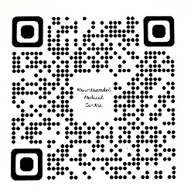

**PATIENT REGISTRATION – INFANTS**

PLEASE COMPLETE ALL OF THE FOLLOWING DETAILS:

Child’s Full Name: _______________________ D.O.B: __________

Parent/Guardian’s Full Name: ____________________________________

Address: ___________________________________________________

Postcode: _____________ Telephone Number: ______________________

Are there any other family members already registered, or planning to register with Mountsandel Medical Centre? YES **□** NO **□**

**If yes, please list their full names and Date of Births below:**

_____________________________________________ ____________

_____________________________________________ ____________

Is this the Registration of a New-born Baby? YES **□** NO **□**

Ethnicity **:** *(Please tick one box!)*

|  |  |  |  |  |  |
| --- | --- | --- | --- | --- | --- |
| British |  | Other White |  | Bangladeshi |  |
| Black African |  | Black Carribean |  | Black Other Mixed |  |
| Chinese |  | Indian |  | Pakistani |  |
| Other (*please state)*: |  |  |  |  |  |

DO YOU REQUIRE THE SERVICES OF AN INTERPRETER? YES **□** NO

Preferred Language? ___________________________________________

***Thank you for completing this Registration Form. Please return to Reception with Child’s Birth Certificate or Yellow Form.***

**____________________________________________________________________**

**For Office Use Only:**

**Date Received ___________ Receptionist’s Name: ____________**

**Registration Approved by GP (signed): ___________________ Date: _____________**